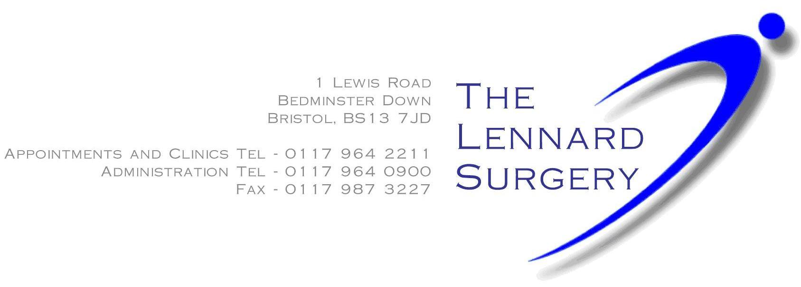PATIENT COMPLAINT FORM
If you have a complaint or concern about the service you have received from the doctors or any of the personnel working in this practice, please let us know. We operate a practice complaint procedure as part of an NHS complaints system, which meets national criteria.
HOW TO COMPLAIN
We hope that we can sort most problems out easily and quickly, often at the time they arise and with the person concerned. If you wish to make a formal complaint, please do so AS SOON AS POSSIBLE - ideally within a matter of a few days. This will enable us to establish what happened more easily. If doing that is not possible your complaint should be submitted within 12 months of the incident that caused the problem; or within 12 months of discovering that you have a problem. You should address your complaint in writing to the Practice Manager (you can use the attached form). He/she will make sure that we deal with your concerns promptly and in the correct way. You should be as specific and concise as possible.
COMPLAINING ON BEHALF OF SOMEONE ELSE
We keep strictly to the rules of medical confidentiality (a separate leaflet giving more detail on confidentiality is available on request). If you are not the patient, but are complaining on their behalf, you must have their permission to do so. An authority signed by the person concerned will be needed, unless they are incapable (because of illness or infirmity) of providing this. A Third Party Consent Form is provided below.
WHAT WE WILL DO
We will acknowledge your complaint within 3 working days and respond to you when fully investigated. When we look into your complaint, we will investigate the circumstances; make it possible for you to discuss the problem with those concerned; make sure you receive an apology if this is appropriate, and take steps to make sure any problem does not arise again.
You will receive a final letter setting out the result of any practice investigations
TAKING IT FURTHER
If this doesn't resolve the problem, or you'd rather not raise the issue directly with the practice, you can direct your concerns to the ICB.
After 1 July 2023, if you feel that the practice is unable to resolve your issues, you should complain directly Bristol, North Somerset and South Gloucestershire Integrated Care Board (ICB) instead of NHS England.
Contact details for the ICB's complaints department are: Email: bnssg.customerservice@nhs.net Telephone: 0117 900 2655 or 0800 073 0907 (freephone)
The Health Service Ombudsman
The Health Service Ombudsman has published a booklet that describes the ‘six principles for remedy’ in relation to complaints handling and involves:
1. Getting it right
2. Being customer focused
3. Being open and accountable
4. Acting fairly and proportionately
5. Putting things right
6. Seeking continuous improvements
If you remain unhappy after everything has been done to try to resolve your concern or complaint you have the right to approach the Ombudsman.
Tel: 0345 015 4033
Web Address: https://www.ombudsman.org.uk/making-complaint

COMPLAINT FORM
Patient Full Name:
Date of Birth:
Address:

Complaint details: (Include dates, times, and names of practice personnel, if known)

SIGNED………………………………….
Print name…………………………
(Continue overleaf if necessary)
PATIENT THIRD-PARTY CONSENT
PATIENT'S NAME: ______________________________________________
TELEPHONE NUMBER: ______________________________________________
ADDRESS: ______________________________________________
______________________________________________
ENQUIRER / COMPLAINANT NAME: _______________________________________
TELEPHONE NUMBER: ______________________________________________
ADDRESS: ______________________________________________
______________________________________________
IF YOU ARE COMPLAINING ON BEHALF OF A PATIENT OR YOUR COMPLAINT OR ENQUIRY INVOLVES THE MEDICAL CARE OF A PATIENT THEN THE CONSENT OF THE PATIENT WILL BE REQUIRED. PLEASE OBTAIN THE PATIENT’S SIGNED CONSENT BELOW.
I fully consent to my Doctor releasing information to, and discussing my care and medical records with the person named above in relation to this complaint, and I wish this person to complain on my behalf.
This authority is for an indefinite period / for a limited period only (delete as appropriate)
Where a limited period applies, this authority is valid until…………………….. (insert date)
Signed: ………………………………………. (Patient only)
Date: ………………………………………….

