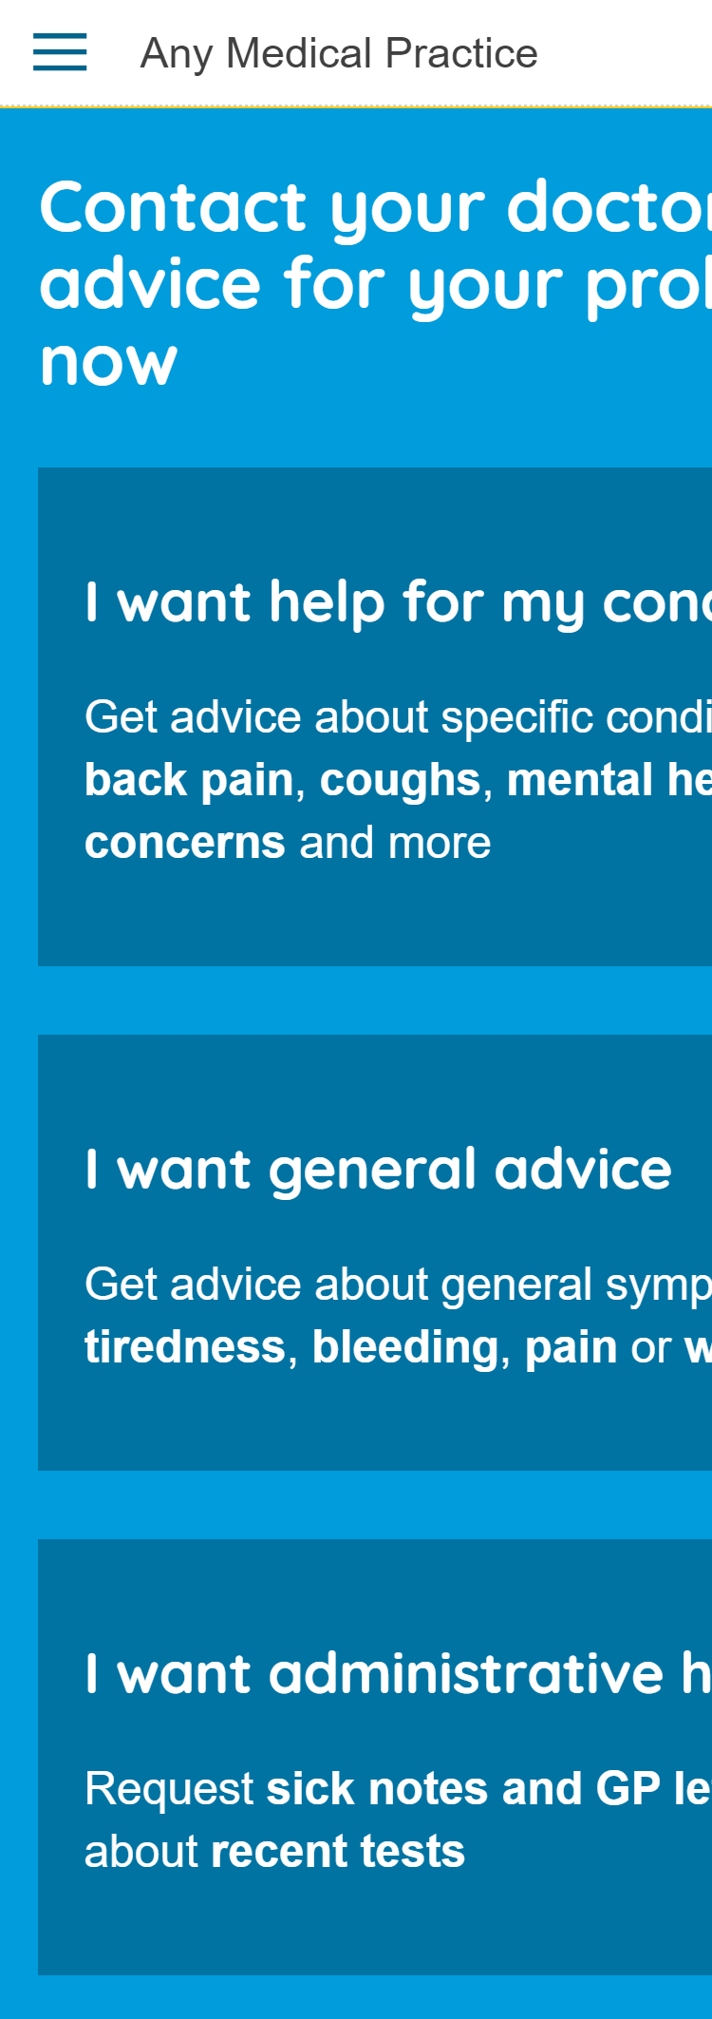
Get the right care when you need it with

eConsult lets patients request medical or administrative help from their own GP practice online, for free, 24/7.

Go to your practice website to start.
Your practice will get back with the right care for you.
More convenient than calling the practice
Give your doctors all the info they need to get you the right care

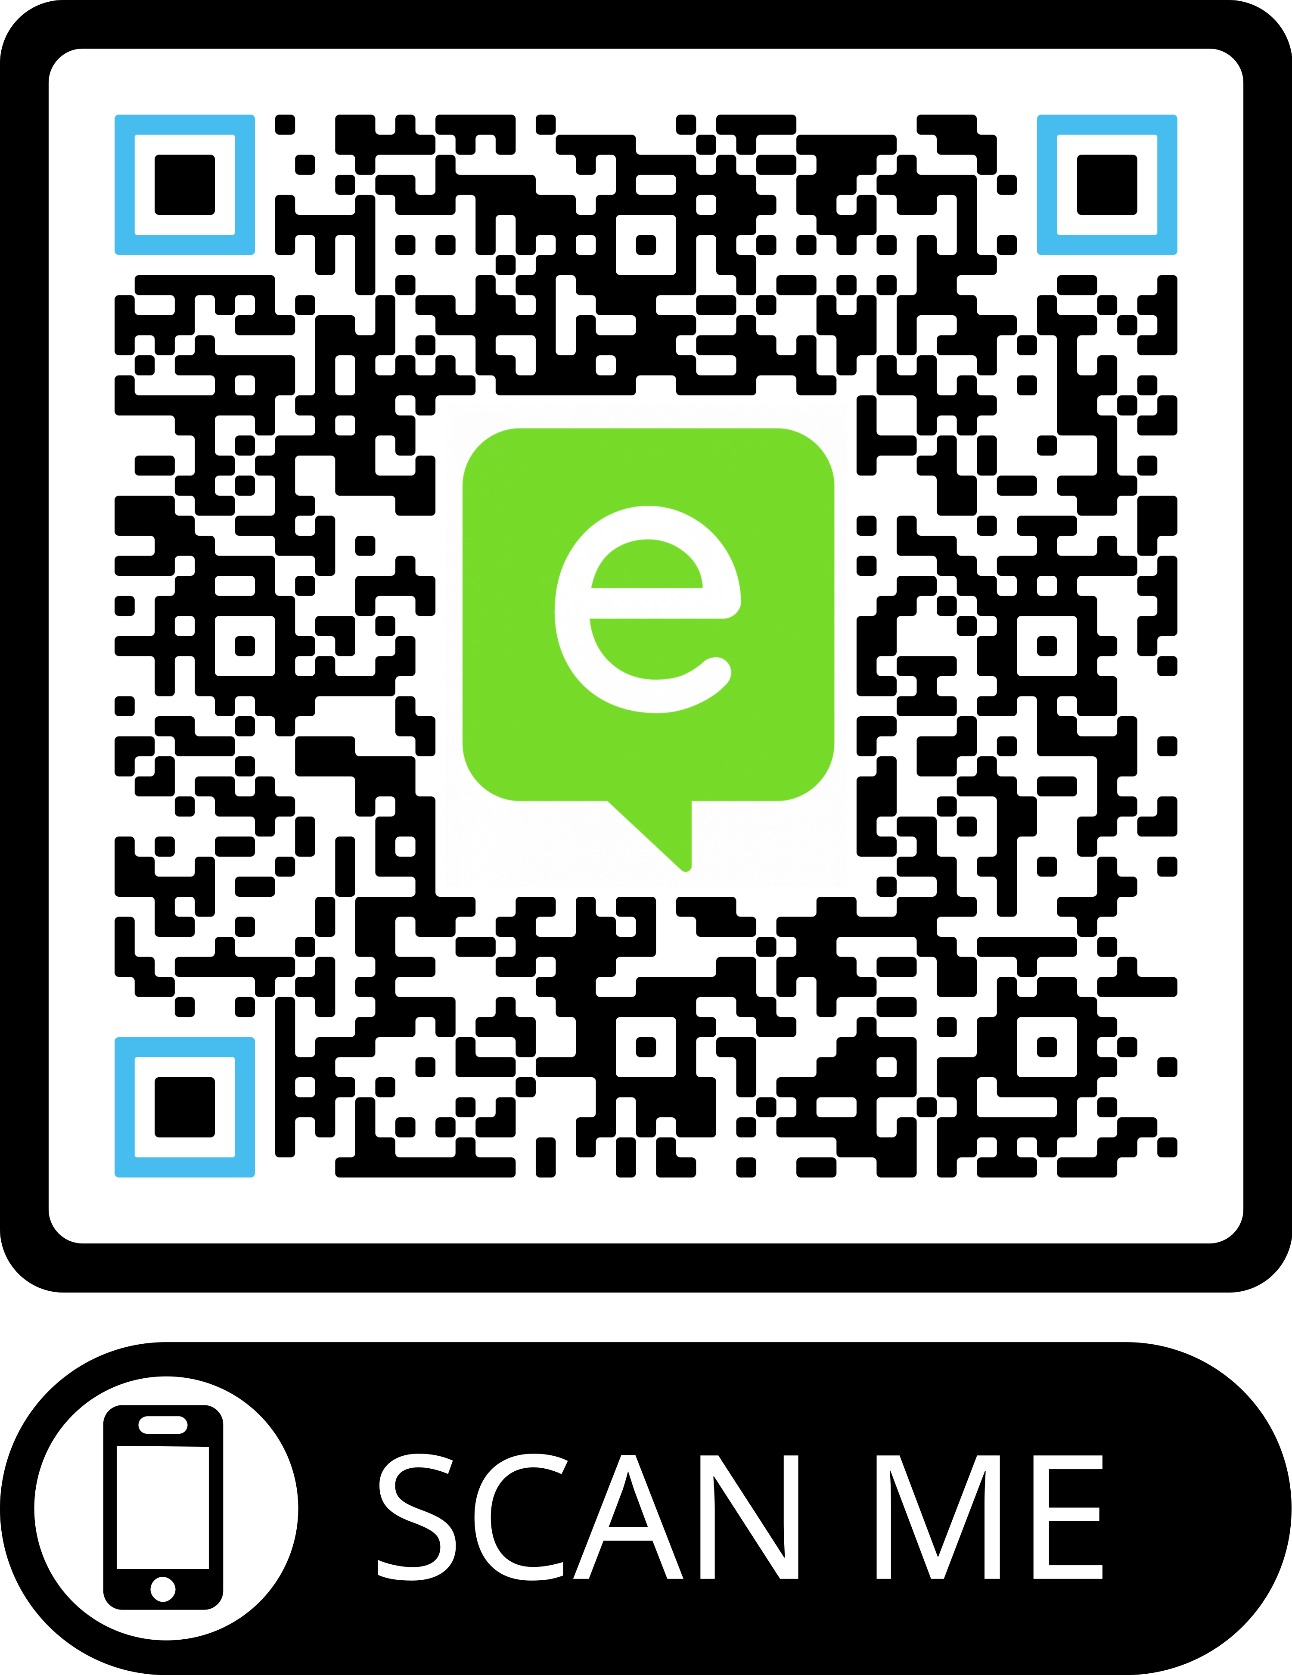
Free up time for your doctors
Available on the NHS App

www.econsult.net/nhs-patients
Available from your practice website

How does eConsult work?
You should use eConsult for anything you would normally contact your GP practice for.
For example: when you feel unwell or if you need a GP letter
Depending on your answers you will be offered different care. If you need an appointment you will get one.
You select either
‘medical’ or ‘administrative’ and answer the questions.
These are sent to your practice to review and decide on the right care for each patient.
Blood tests

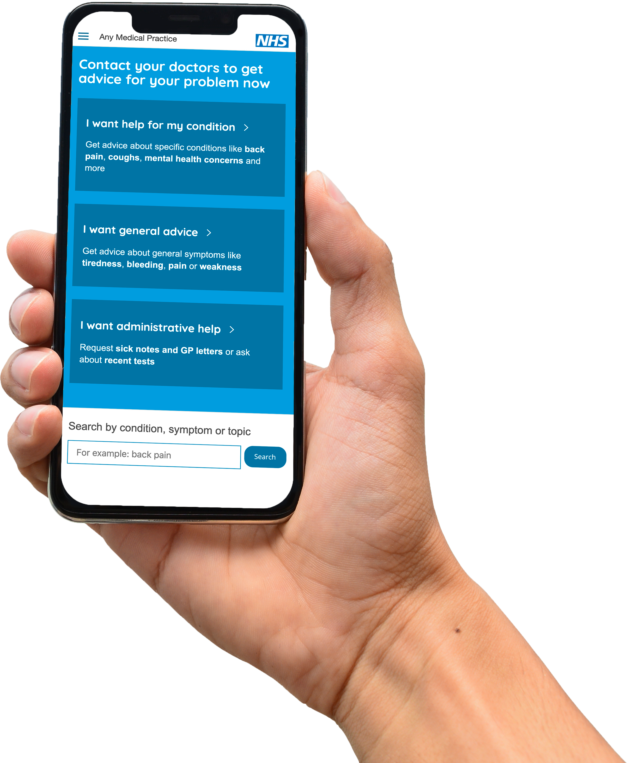
When you need to contact your practice, submit an eConsult from anywhere you have internet via your PC, phone or tablet.

When can you use eConsult?
Your data is safe. eConsult does
not store any identiﬁable patient information. It goes direct to the practice.

When you feel unwell or want medical advice from your GP practice.

When you need reassurance from your doctors of what is best to do - for you or your children.
When you have an administrative request such as requesting test results,
Blood tests
a sick note or asking questions about medications.

Why should you use eConsult?

You can submit an eConsult 24/7 from anywhere you have internet connection.

The structured questions ask everything your doctors need to safely get you to the right care.
Fit notes
Medical Report
GP letters
Patient safety is key. Our red-ﬂagging alerts doctors to your conditions and directs you to more critical care if needed.

Available on the NHS App

Available from your practice website

eConsult Health Ltd. | www.econsult.net Business address: eConsult Health Ltd, Moorfoot House, 221 Marsh Wall, London, E14 9FJ Registered address: Nightingale House, 46-48 East Street, Epsom, Surrey, KT17 1HQ Registered in England and Wales under company number 07628675

